<BDM Final Submission>Analysis Of Stationery Sales

short line

Kanishk Bajpai   
(21f2000784)  
2nd March, 2023

Submitted To:  
IIT MADRAS, BDM TEAM

# Introduction

1. Executive Summary & Title
2. Detailed Explanation of Analysis Process/Method
3. Results & Findings
4. Interpretation of Results & Recommendations
5. Presentation & legibility of report

# 1.Executive Summary & Title

This capstone project is intended to help a stationery shop owner to understand the strategies he has to implement after analyzing sales data of the 2 years, and to maximize and stabilize the profit in the principal revenue he produces from selling Stationery items, and help with his sales.  
The shop also deals with Telecom businesses & in the area of Photocopy as well.  
[Baba Vishwanath Photocopy And Recharge Centre](https://www.google.com/maps/place/Baba+Vishwanath+Photocopy+And+Recharge+Centre/@26.4157724,80.3860761,19.72z/data=!4m5!3m4!1s0x399c4122ef08779d:0x6f1b87534ddece20!8m2!3d26.4156245!4d80.3861731?shorturl=1)

I have got a **short cumulative Stationery data** to analyze…  
[Stationery Sales](https://docs.google.com/spreadsheets/d/1RTkyi8UMs-HI-HT_Q220cutizNWrR9ICXyFosw5dYVI/edit#gid=393801185)

With the Dataset that I have as part of the project, I will be able to help the stationery shop owner, that he should choose to sell, with the amount of supplies of these items that he should sell to make profit and also help him to manage stock outs and some other business related problems.

The primary goal of this project so far is to examine the sales trends in order to improve the store’s ability to generate revenue from this category. Because of the launch of new products into the businesses, sellers constantly face the prospect of not reflecting a stable relation with customers & timely customer reviews.

The most appropriate title for this project would be **"Analysis of Stationery Sales"** because it focuses on resolving challenges faced by a Stationery Shop using information from trend analysis.  
  
As I am currently in IIIT Dharwad, Karnataka, I faced difficulty in asking about this data from my relative residing in Kanpur, UP, about 2000 km away from me, because he doesn’t know how to use technical stuff, I faced difficulty in getting the data one by one, and uploading and organizing it accordingly…till now it’s not completed yet…still going on..

# Additional Miscellaneous Problem faced:

1. Not Using UPI/ QR Code as a convenient and an additional mode of transaction.
2. Not having global online reach using website or any application
3. Not there in affiliate Marketing
4. No Marketing / Advertisements

# 

The following are the images of the Shop:

Address:

183, Subhash Road, Ramgali, Harjinder Nagar, Ramadevi, Lal Bangla, Kanpur, Kanpur Nagar, Uttar Pradesh 208007  
[Baba Vishwanath Photocopy And Recharge Centre](https://www.google.com/maps/place/Baba+Vishwanath+Photocopy+And+Recharge+Centre/@26.4157724,80.3860761,19.72z/data=!4m5!3m4!1s0x399c4122ef08779d:0x6f1b87534ddece20!8m2!3d26.4156245!4d80.3861731?shorturl=1)

[Click Here to get its Google location](https://goo.gl/maps/1mv51gmmFxKToyoPA)

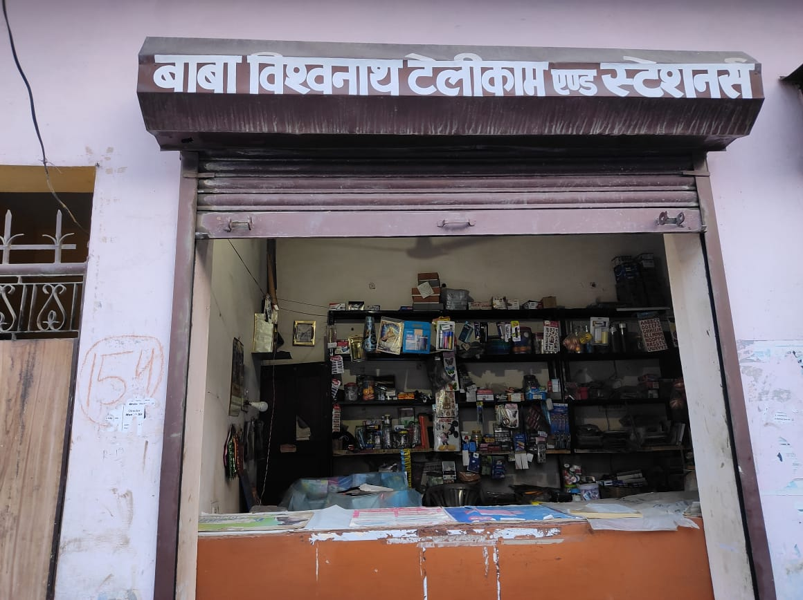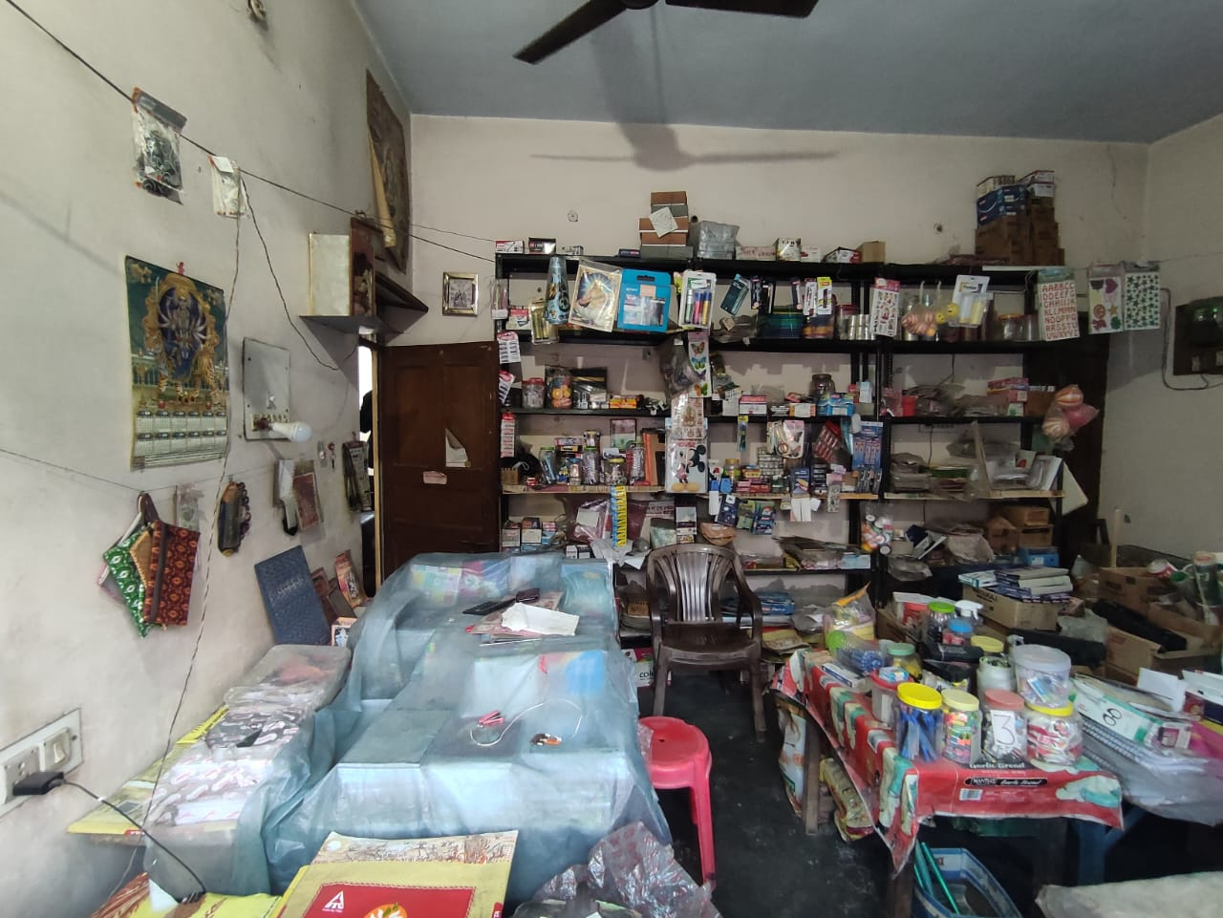

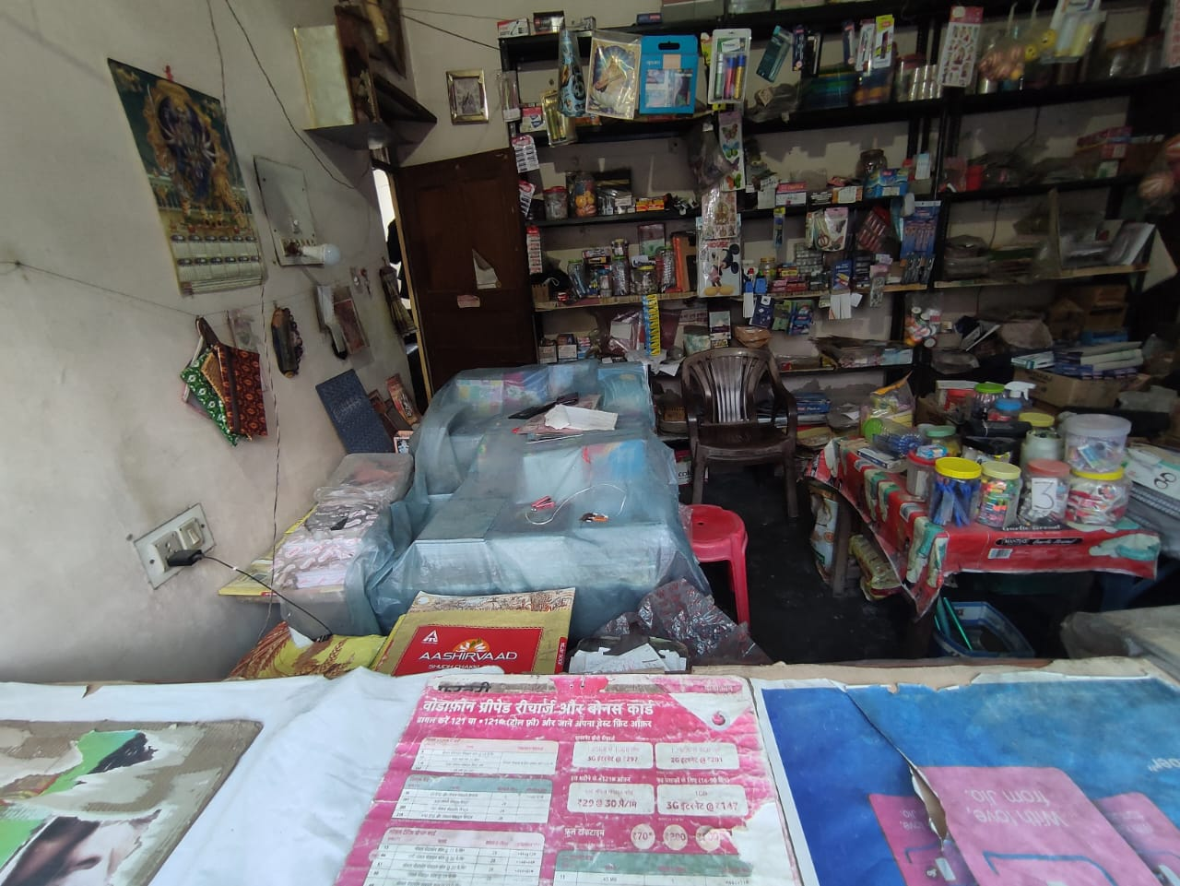 

[Stationery Sales](https://docs.google.com/spreadsheets/d/1RTkyi8UMs-HI-HT_Q220cutizNWrR9ICXyFosw5dYVI/edit#gid=393801185)  
[Click here to see the DataSet](https://docs.google.com/spreadsheets/d/1RTkyi8UMs-HI-HT_Q220cutizNWrR9ICXyFosw5dYVI/edit?usp=sharing)

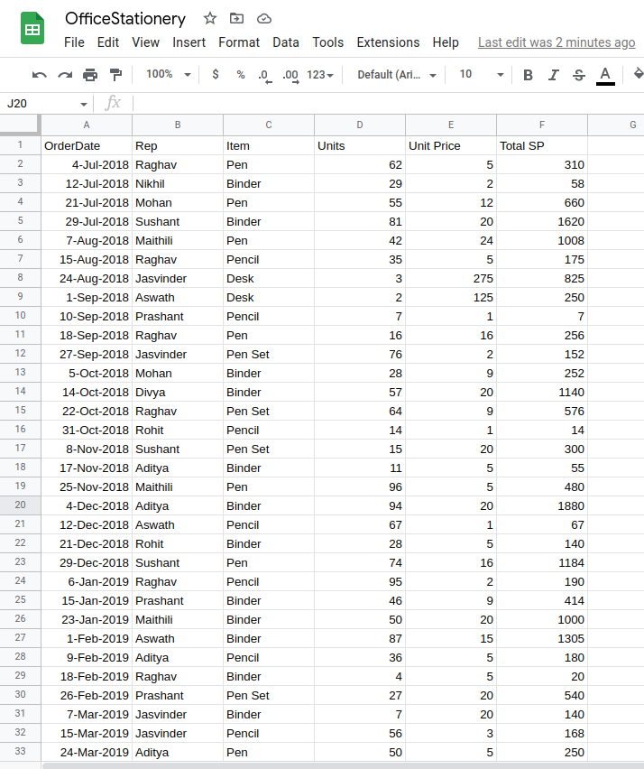

# 2. Detailed Explanation & Analysis/Project

There are many types of Analysis we can perform, but we will do only those which are according to data collected

1. Survey Data
2. Utility & Prices
3. Demand & Supply Curve
4. Costing & Pricing Strategies
5. Pareto Analysis (80/20 Principle)
6. Sales Analysis
7. Scatter Chart
8. Ledger
9. Revenue
10. Scrap
11. OEE

**Costing and Pricing Strategy**

Costing is the process of calculating the total cost of producing a product or service, including all direct and indirect expenses, such as materials, labor, overhead, and other expenses. The goal of costing is to determine the actual cost of producing a product or service, which is important for setting prices and determining profitability.

Pricing strategy, on the other hand, is the method of setting prices for products or services in a way that maximizes revenue and profitability. A company can use various pricing strategies, such as cost-plus pricing, value-based pricing, competitive pricing, or dynamic pricing, depending on their business goals, competitive landscape, and customer preferences.

The costing and pricing strategy are closely related since the price of a product or service should be based on its cost, along with other factors such as market demand, competition, and customer perceived value. By using costing information to inform pricing decisions, businesses can set prices that cover their costs while remaining competitive and profitable. A well-designed pricing strategy can help businesses optimize their revenue and profitability while meeting the needs and expectations of their customers.

**Pareto Analysis**

Pareto Analysis is a decision-making tool that is based on the Pareto Principle, also known as the 80/20 rule. It states that roughly 80% of effects come from 20% of causes. In business, this means that a small number of factors often have a disproportionately large impact on performance.

Pareto Analysis involves identifying and prioritizing these key factors. This is done by collecting data on the causes and effects of a problem or opportunity, and then plotting it on a Pareto Chart. The chart allows you to see which factors are the most important, and to focus your efforts on addressing them.

By using Pareto Analysis, businesses can prioritize their resources and efforts to achieve the greatest impact. It can be used in a wide range of applications, from quality control to customer service to marketing.

**Sales Analysis**

Sales analysis involves examining and interpreting data related to sales to identify patterns, trends, and insights that can inform business decisions. Key metrics to analyze include total sales revenue, sales volume, customer acquisition and retention rates, average order value, and profit margins.

Sales analysis can help businesses identify their best-performing products, sales channels, and customer segments, as well as areas for improvement. For example, if a business notices a decline in sales revenue, they can use sales analysis to identify the root cause, such as changes in market demand, pricing, or product quality, and take corrective action.

Sales analysis can help businesses make data-driven decisions to improve sales performance, optimize pricing strategies, and enhance customer satisfaction and loyalty.

I have attached a ScreenShot of my DataSet   
  
  
  
I have attached Pivot table out of my DataSet below  
  
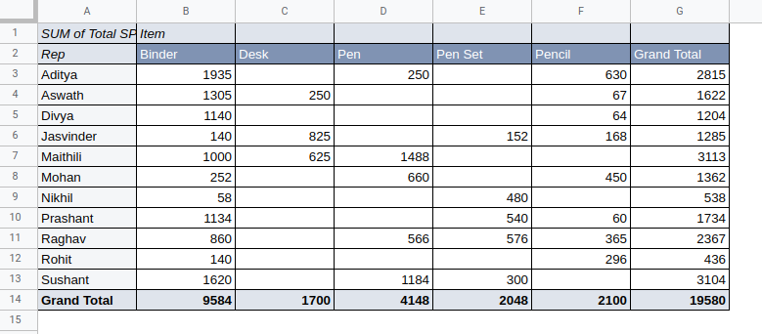  
  
  
I have attached Pie Chart of the DatSet of Customers V/s Items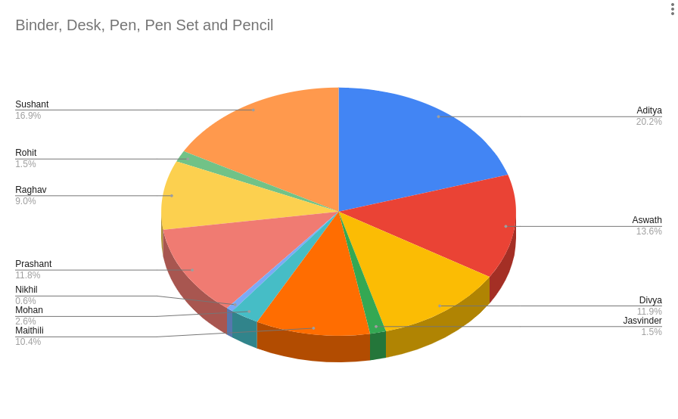

# 

The above collected data can be analyzed using the Pivot Table Analysis and Charts function present in Google SpreadSheet.

* Firstly finding Highest/Lowest Sale through a particular customer.
* Secondly using the Pareto analysis which is premised on the idea that 80% of a profit can be achieved by selling 20% of the Items.
* Thirdly I will try to implement Scrap Analysis in the DataSet, since I am trying to upload it manually in a spreadsheet, it will take some time to analyze.
* OEE(Overall Equipment Effectiveness), in the process of sale from ***Manufacturer to Customer.***

| * **OEE = Availability ✕ Performance ✕ Quality** |
| --- |

# 3. Results & Findings

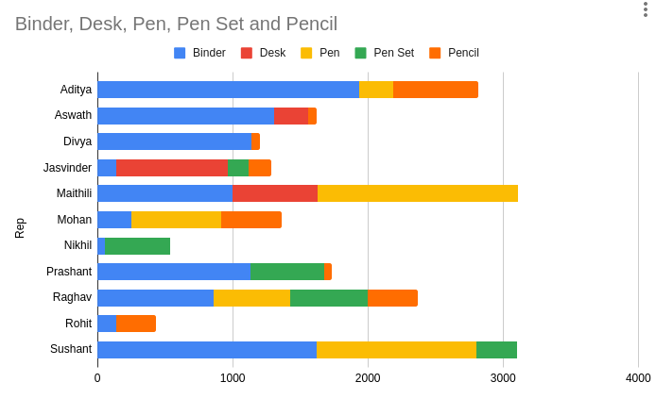

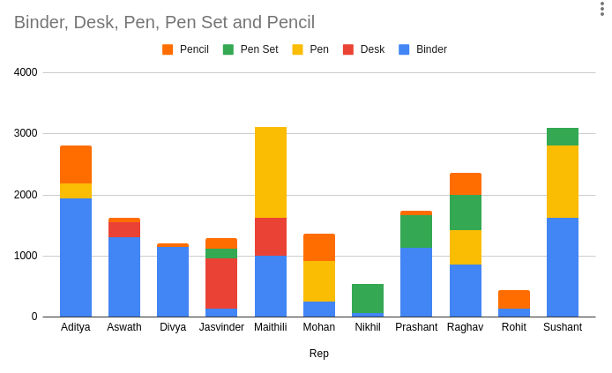

# Total Purchase by Maithili, Sushant & Aditya is among the highest **around** 3000 Rs each.

Pareto Principle states that 80% of the sale is through your 20% of the customers, but if see our Dataset, it is not applicable as if we take total sale of top 3 customers then it is around 9000 Rs, but Grand total is around 19000 Rs which comes out to be 48% .  
Because the **sample size that I have got for this project is small**.

**Sale also majorly depends on:**

1. Market competency,
2. Geographic location,
3. Method of transaction,
4. Online Availability
5. Ease of availability of the stock,
6. Shop timing,
7. Customer Service & Relationship,

These are also to be analyzed,

**Market competency** is high, because there are stationery shops nearby which affect the sales

**Geographic Location**: There are few schools and one college within 1 km radius of the shop.

**Method of Transaction**: It is a major problem in this business, because many businesses nowadays nearby use UPI transaction as an additional mode of transaction, but this shop supports only on cash transactions.

I will help my uncle in establishing the UPI transaction system, to go cashless.

**Online Availability**: Some of the premier shops in the market already exist in the world of internet with their own website, and customer services, but this shop doesn't have any online visibility or marketing.

I will try my best to create an online shopping website, selling in Amazon/Flipkart to get more customers and reachability.

# 4. Interpretation of Results & Recommendations

**Market competency**

In order to recommend an increase in sales in a competitive market, focus on understanding the target audience and their needs, differentiate your product or service from competitors, offer exceptional customer service, utilize effective marketing strategies, and continuously analyze and adapt to market trends and consumer behavior.

**Geographic Location**

In order to recommend an increase in sales in a particular geographic location, consider targeting advertising and promotions to the specific audience in that area. Can also partner with local businesses or organizations to increase visibility and credibility. Offering special discounts or incentives to customers in that location can also help to drive sales. Finally, ensure that your products or services meet the specific needs and preferences of that particular market.

**Method of Transaction (Online Payment)**

In order to recommend an increase in sales using a particular method of transaction, you can offer incentives or discounts to customers who use that method, promote it through targeted marketing campaigns, simplify the checkout process, provide clear instructions and support, and gather customer feedback to improve the user experience.   
Ex: UPI enabled transactions, Swipe Card, Wallet Payment…etc

**Online Availability**

In order to recommend an increase in sales using online availability, optimize your website for search engines, provide detailed product information, offer secure payment options, implement customer reviews, and use social media and email marketing to promote your products. Additionally, consider offering special promotions and discounts to encourage customers to make a purchase.

**Ease of availability of the stock**

In order to recommend an increase in sales by improving the ease of availability of stock, you can consider the following steps: optimize inventory management, ensure adequate stock levels, improve distribution channels, provide multiple purchasing options, simplify the ordering process, and utilize technology such as e-commerce platforms and mobile ordering.

**Shop timings**

In order to recommend an increase in sales using shop timings, consider extending your hours of operation to accommodate customers who may have busy schedules. You can also conduct market research to identify peak shopping times and adjust your schedule accordingly. Additionally, promote your new hours through social media and other marketing channels to increase awareness and attract more customers.

**Customer Service & Relationship:**

In order to recommend an increase in sales through customer service and relationship building, focus on providing excellent customer experiences, personalized attention, and timely responses to inquiries or concerns. Encourage customer feedback and use it to improve your products or services. Build trust and loyalty by going above and beyond to meet their needs.

short dash